Movies and Relationships
1. Find out your classmates’ favorite movies of all time. Complete the table and share your findings with
the class.

No. | Categories | Movie Title | Classmates Survey
1. | The best movie
2. | The scariest movie
3. | The funniest movie
4. | The most romantic movie
5. | The saddest movie
6. | The cheapest movie
7. | The most expensive movie
8. | The most boring movie
9. | The most educative movie
10. | The worst movie

2. Read the following information. Then with your friends in the group, complete the table based on your
findings from your classmates.

Relationships | Your Choice | Classmate Survey | Indonesian Movies | English Movies (Hollywood) | Other Movies
Friendship
Family Relationship
Romantic Relationship
Professional Relationship

Note:
Power distance is a term that describes how people belonging to a specific culture view power relationships - superior/subordinate relationships - between people, including the degree that people not in power accept that power is spread unequally.
Individuals in cultures demonstrating a high power distance are very deferential to figures of authority and generally accept an unequal distribution of power, while individuals in cultures demonstrating a low power distance readily question authority and expect to participate in decisions that affect them.
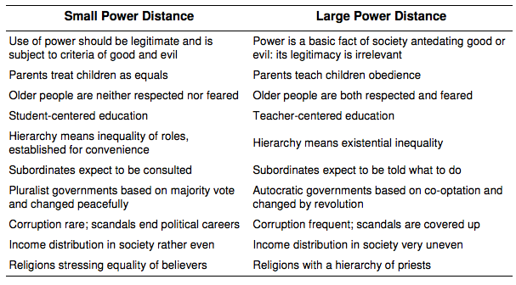
(Retrieved from http://www.wikiwand.com/en/Hofstede's_cultural_dimensions_theory)

